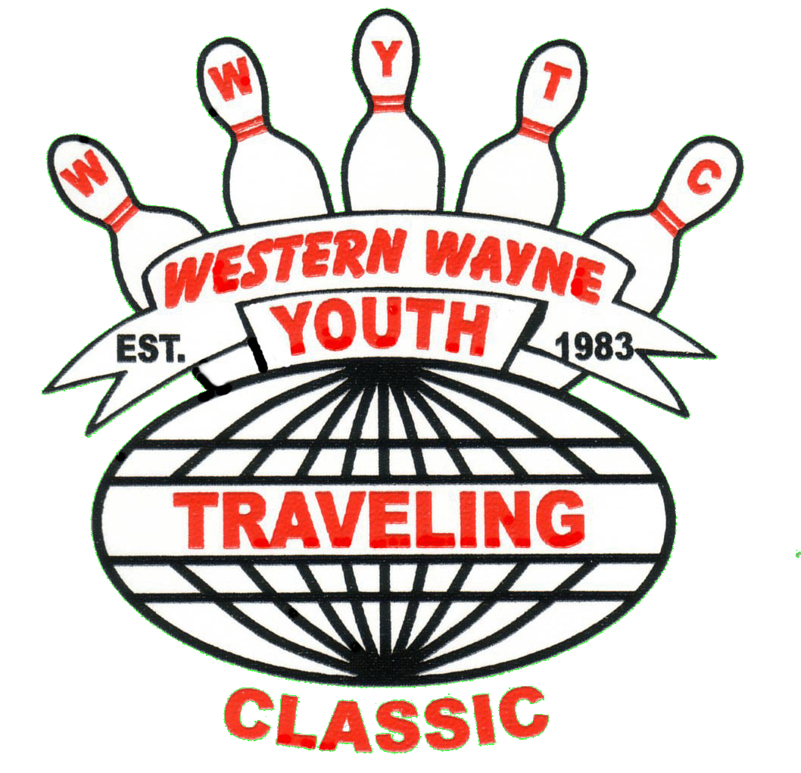 Western Wayne Youth Traveling Classic
_____________________________________________________________
Westland, Michigan 48186 (313) 378-2607
______________________________________________________________________

2020-2021 League Rules

1. NAME/HOUSES
The name of the league is: WESTERN WAYNE YOUTH TRAVELING CLASSIC. The league may bowl at the following houses (depending on lane availability etc.): Plaza Lanes, Woodland Lanes, Lodge Lanes, Oak Lanes, Thunderbowl, Super Bowl, Merri Bowl, Vision Lanes, and Westland Bowl.

2. STARTING DATE/TIME
The league will start on Sunday, September 27, 2020 at Oak Lanes at 10:00 AM. Bowlers will be allowed 10 minutes practice beginning at approximately 9:50 A.M. Bowlers must start scoring when the announcement is made, no later. There are NO Exceptions! This league will bowl up to 19 weeks of regular bowling, and may include the Western Wayne Youth Association Championship Tournament. WE GO BY THE HOUSE CLOCK FOR STARTING TIMES, NOT YOU’RE WATCH! When a bowler calls to notify his/her Captain that he/she will be late then he/she has until the completed Baker game to show up or else a sub will be placed. When a sub is placed he/she will bowl all three games for that day. (This rule will be enforced, it is not fair to place subs and then make them move back and forth.) Please show up on time! The tardy league bowler will be allowed to bowl on the sub lanes, and still have to pay the weekly fee.

3. TEAM ROSTER
It is the responsibility of the team’s member’s to fill their team roster. The order used will be;
a. Returning bowlers that were on the roster from the previous season
b. Eligible subs from previous season roster.
c. Bowlers that bowled in the Singles League
d. Bowlers who attended the clinic/meeting that meet WWYTC criteria and are interested in bowling in the league.
e. Only after all of these avenues are exhausted will team members be allowed to bring in their own bowlers outside these requirements.

Teams will consist of 4 bowlers. It is preferred that the teams be Mixed, but not mandatory.
There must be 1 team member and a sub to bowl or the team will forfeit the game.
a) Pre bowl scores will count as a second bowler (one bowler and one pre bowled score)
b) Team Captain’s phone numbers must be available to all other Team Captains. The League Secretary will provide a copy.

4. ENTERING AVERAGES
The minimum entering average (For New Bowlers) needed to qualify to be on a team, is 160 for boys and 140 for girls.
If after 9 games a league bowler is not at or exceeding the league entering average, he/she must stay after for bowling instructional purposes. If after 5 weeks a league bowler is not at the entering average, this could be cause for the bowler to be removed from their team and put on the sub list.
New bowlers will use last year’s highest Yearbook Average. WWYTC bowlers will use last year’s league average.
If the bowler does not have a yearbook average, then a current league sheet will be needed to verify the average. If a league sheet is not available, then after the bowler has bowled their first 3 games, their entering average will be determined.
- Bowler’s new averages will be figured after 9 games of bowling.
- Summer league averages will not be used.

5. HANDICAP
Each team will receive handicap of 80% from 800. If a team is over 800 they will give up 100% of the difference they are over 800. If both teams are over 800 then it is simply 80% of the difference between the two teams.

6. POINT SYSTEM
The league will use a modified Peterson Point System. Teams will bowl for 1 point per game, 2 for totals and 2 points for a Baker Game. Teams may receive additional points when bowlers reach or exceed their averages for the game; 1 point per bowler per game, maximum of 12 points. Total points that can be taken are 19 Points. You will bowl for points the first day. Baker game doesn’t count towards Totals. Baker game will be bowled first.

Baker Game Rules and Bowling rotation.
a) Bowlers may choose the order they like to bowl the Baker Game. It does not have to be the same order in which you bowl the three game league sessions.
b) Handicap shall be 25% of the handicap for the normal league play. (Example: If a team receives 60 pins a game in the regular session, they would receive 15 pins for the Baker game.)
c) No average points will be awarded for a blind bowler.

7. LEAGUE RECAP SHEETS
Only a league bowler is to fill in the recap. PARENTS AND / OR GUESTS ARE NOT ALLOWED IN THE SCORING OR SETEE AREA. Captains will verify addition with the calculators provided before turning in the scorecards. Captains are responsible financially for lost calculators.
It is the winning Captain/Representative’s responsibility to turn in the score card with calculator to the League Secretary. Score cards must be completed and signed by both Captains. Failure to do so will result in a $5.00 fine.
a) If the Captain is not present, then a representative from the team may sign the scorecard.

8. SUBSTITUTES
Subs: A Sub is defined as a league member who has paid all the required league fees, but is not part of a team roster. Subs are the only ones who are eligible to bowl in place of a regular bowler.
WWYTC subs are required to pay the $25 Registration fee, purchase and wear the league approved uniform (shirt and pants). Shirts will be ordered after they bowl nine games. Subs must sign the League Code of Conduct also. All league rules apply to subs.
All subs must sign in at the Director’s Table. The team captain is responsible for signing the “Request for Sub” sheet. No “SUB” can be specifically requested except in the case of extended illness or injury. Teams must accept an available “SUB” providing the “SUB” has attained the required average. Vacancies will be filled according to the order of the captain’s sign in sheet. Teams only have an option of accepting/refusing a “Sub” if their league averages fall below the required league average. On a position round subs will be allowed to bowl. Subs must have at least 9 games bowled by the first position round, 15 games by the second position round, 24 by the third position round, 29 games by the fourth position round, 39 games by the fifth, 42 games by the sixth, 45 games by the final position round. Subs will be allowed to pace on a position round.
- Subs without a WWYTC average must bowl 9 games to be eligible to sub on a team.
9. ABSENT BOWLERS
When a bowler is absent and a sub is unavailable, the bowler’s average minus 10 pins is used.

10. UNOPPOSED BOWLING.
You must bowl within 40 pins of your team average when bowling unopposed to win a point. Teams bowling the Baker game unopposed will automatically win the two points for that game.

11. POSITION ROUNDS
The league is a full season league with appropriate position rounds on weeks to be determined by the board.

12. PRE/POST BOWLS
Team Postponements or Pre-bowls are allowed including Position Rounds. A request must be made 24 hours before bowling to the league Pre-bowl director (Mike Macunovich 734-787-3891), who will set up the date and time.
- No Baker frames required for pre bowl. Baker games will be bowled by the legal line up present on the scheduled day of bowling with the rest of the league.
b) All make-ups must be bowled in the house where the Post/Pre-Bowl is scheduled, if lanes are available. All postponements/pre-bowls must be done prior to the next scheduled bowling day. (PRE-BOWLS WILL BE LIMITED TO 3 PER SEASON)
c) If a team is approved to pre-bowl they must bowl a baker game and add that game to the pre-bowl score sheet presented to the league secretary, along with the team scores.
d) Team Captains must notify all Team Members of the date and time of Post/Pre-Bowls. ALL TEAM MEMBERS MUST BOWL AT THE SAME TIME!
e) Individual Pre-Bowl: as approved by the Board of Directors. All pre/post bowls MUST be approved by the pre-bowl director prior to bowling. If the bowler fails to get proper approval scores will not count! The team will then take that bowlers average minus 10 pins.
f) Individual Post Bowl: Only Bowlers making the cut in a multi day Tournament (i.e. MJMA or JTBA) that are not able to bowl on Sunday because they made the cut, may post bowl, but they must notify the League Secretary that Saturday evening, (before Sunday’s League session), to schedule a Post Bowl.
g) Bowling out permitted 8-9-10 frames only with Board of Directors’ approval.
h) Once you pre/post bowl those scores must be used.
i) Pre/Post bowls do not count toward the Kluska Tournament or the weekly over average competition.
j) No pre or post bowls will be allowed on the last league session whatsoever!

13. RESIGNING BOWLERS
If a league bowler resigns, that bowler must give his/her Captain or a Director 2 weeks’ notice. The resigning bowler is responsible for the next 2 weeks bowling fees. Once a bowler resigns, he/she cannot rejoin the league until the following season (including pacing or subbing). Any bowler absent 2 weeks in a row without notifying a Director can be replaced. If the team cannot replace the bowler, an average of 150 will be used for the next 2 weeks. If a replacement is not found, 160 will be used to figure the handicap until a bowler is found.

14. BOWLING FEES
Bowling fees will be $12.00 per bowler per week for 19 weeks. All subs will pay $12.00 to bowl three games. There is no absent fee for subs. Regular bowlers will pay $12.00 even when he/she does not bowl, making this league a guaranteed league.
a) The last two weeks of bowling must be paid by the fifth week.
b) It is the Captain’s responsibility to see that bowling fees are turned in, to the League Treasurer, by the end of the 3rd frame of the 1st game.
c) Bowlers will not be allowed to join us at the WWYTC Banquet if they owe the league money

15. REGISTRATION/SPONSOR FEES
Teams must have a sponsor. Anyone wishing to sponsor a team please see Jeff Elswick or George Bell. League Members must pay a $25.00 Registration Fee by the 3rd week of bowling.

16. ARREARAGES
No bowler may be more than 1 week behind in league fees or fines. If a bowler is behind, all money in arrears must be made up the following week. They cannot bowl until all money owed is paid and/or all suspensions are served. Bowlers will be dropped from the league for non-payment of league fees and forfeit any trophies they may have won.
- The league will accept checks for payment of league fees until a check “Bounces” or is returned for non sufficient funds, then its cash only for that bowler- NO EXCEPTIONS. If the league is charged for a bad check, the writer of the check must reimburse the league the full amount.

17. TOURNAMENTS
Bowlers will prepay their own team event fees for the Western Wayne County USBC Youth Association Championship Tournament and the Michigan State Youth Tournament. Once they have appeared for the tournament(s), (On Time and in Proper Uniform) they will be reimbursed for one (1) team event fee at the end of the season WWYTC Banquet. (If you bowl all 9 games (Team/Doubles/Singles) with WWYTC you will be eligible for reimbursement for 1 team event fee). A minimum of 24 hour’s notice must be given to the tournament director, if a bowler needs to be replaced.
a) A bowler will be considered tardy if they do not attend the league meeting before the tournament. The league meeting will take place ½ hour before the tournament scheduled check-in time.
b) The fine will be waived only in the case of an emergency (verified illness, accident, death in the family). A phone call to a director, bowling center, or designated cell phone number should be done as soon as possible so substitutions can be made. Phone numbers will be made available prior to the tournament. If you are bowling in a two day tournament (i.e. MJMA, JTBA, or similar tournament) and qualify for the next day, you must call the Tournament Director as soon as you are notified so a sub can be found.
c) All payments for tournaments must be made by the cutoff date that will be set for each tournament. You will not be placed on a team until total payment is made. If you are late with your payment you will be placed on a waiting list and will be added to a team when a spot opens up.
d) All tournament money is non-refundable.

18. SCHOLARSHIPS
1. The Norm Kluska Scholarship. This scholarship opportunity is comprised of the last six weeks of league bowling. You will use your highest five weeks for scoring purposes. Scores will be handicapped at 80% from 220. All SMART Scholarship Program rules and regulations apply to this scholarship opportunity.
a) Bowlers must be league members in good standing.
b) The bowler’s must have bowled 2/3 of the bowling season.
c) The bowler must meet average requirements. (Rule #4)
d) The top 4 places will be awarded points that can later be applied for and converted into scholarships after all USBC requirements are met.
2. The bowler with the most pins over average every week will receive points toward a future scholarship in two divisions, to be determined by the Secretary when the roster is set before the season starts. Points will be deposited in the USBC Smart Scholarship Program as long as the following requirements are met:
a) Bowlers must be league members in good standing.
b) The bowler’s must have bowled 2/3 of the bowling season.
c) The bowler must meet average requirements. (Rule #4)
d) Bowlers will use their average as of 9 games.

3. Any future U.S.B.C. rule changes that apply to scholarships will apply to all of the opportunities that this league offers.

19. DRESS CODE
WWYTC’s Dress Code is as follows:
a) Absolutely - NO JEANS are allowed or anything that even looks like Jeans.
b) Boys will wear black, plain straight leg dress pants. These pants should look casual/dressy. They may not have cargo pockets, zippers, piping, stripes, elastic waistband or be baggy. Dress/golf Dockers are acceptable.
c) Girls will wear black, plain dress slacks, or black Capri’s the same restrictions apply as above (boy’s pants) or a skirt or skort no shorter than the tips of their fingers held by your side are acceptable. No designs or appliqués permitted. No Yoga or Jegging pants allowed.
d) Shirts must be tucked in at all times
e) Bowlers may wear shorts all season the same rules apply as for the pants.
No cut-offs. They must be dressy.
f) If your pants, shorts etc. have belt loops, you must wear a belt.
g) Bowlers will wear their league approved uniforms to all Tournaments and League functions unless otherwise directed by the Board of Directors. This means Team, Doubles and Singles events. Bowlers are required to wear their league approved uniform to pre/post bowls.
h) If a bowler is found to be in uniform violation at the Association Championships or State Tournament, they will be fined $20.00.
i) Directors will vote on any exceptions to the above rules.

Bowlers Must Wear Their League Approved Shirt with Name on Back, Pants, Shorts, or Skirt/Skort Every Week!
a) Penalty for non-compliance:
b) If a bowler is to be found in uniform violation after bowling has begun, the bowler will be allowed to finish the game that they are bowling. After that game is completed the bowler will not be allowed to bowl any remaining games. The bowler’s average minus 10 pins will be used instead. Rule 25 concerning infraction rules penalties will also be issued at this time.
c) Bowler cannot bowl that week and must pay weekly bowling fee plus infraction rule penalties.

20. ETIQUETTE
Lane etiquette is one clear approach on either side of the bowler. Stay off the approach until it is your turn to bowl. Each bowler can have only 1 ball on the rack. Extra balls are to be kept out of the way of other bowlers as much as possible.

21. CONDUCT
Unsportsmanlike conduct such as profanity, inappropriate gestures, the misuse of bowling establishment property, temper tantrums, inappropriate displays of affection, ETC. will result in the following:
1st offense is a $5.00 fine which doubles that day for further infractions
Gambling is an automatic WWYTC League Suspension.

22. CONDUCT/RULES
a) All league bowlers must read and sign the League Rules sheet. Those bowlers under the age of 18 must also have a parent or guardian sign.
b) The Board of Directors will be governed by a Code of Conduct. A copy is on file with the League Secretary.

23. PRACTICE BOWLING
Practice bowling is allowed on any lane EXCEPT the lanes being used by the league on that day. Penalty for infraction of above rule is as follows:
You are not eligible to bowl that day; bowler must pay bowling fee and a $5.00 fine.

24. CELL PHONE/VIDEO GAMES
There will be No playing of video games by league bowlers while any of the league is still bowling.
No phone calls or text messaging during League session, emergency calls may ONLY be made with Directors permission.
Any and all electronic devices must be put away! Do not have them out at all!

25. FINES AND PENALTIES
League Rules Infraction Penalties are as follows:
1st Infraction: Written warning and or a $5.00 fine
2nd Infraction: $10.00 fine
3rd Infraction: Hearing before the Youth Officers to determine the penalty.
Tardy Bowler: 1st time warning, 2nd time a $5.00 fine and 3rd time will have a hearing before the Youth Officers to determine the penalty.
a) Sergeant At Arms and Sergeant At Arms Liaison will handle all league discipline.
b) Any penalties or fines given at TOURNAMENTS for dress code and behavior will be DOUBLED.
c) All captains and League Officers are required to wear the medal badges given to them at the beginning the season describing their position in the league. They are to be worn on the upper left side of their shirt at the approximate line of the second or third button centered on the shirt. Lost badge is $10. Failure to wear badge see rules infractions above. Badges must be returned to Sgt. of Arms at end of season. Failure to return your badge will result in a $10 fine.
Multiple rules infractions on the same day will result in a hearing, to be held before League Officers & Team Captains, on the next scheduled bowling day, to take place ½ hour before bowling, unless told otherwise. Outcome of meeting could lead to lifelong suspension from WWYTC. Failure to attend the meeting will be cause for permanent dismissal from WWYTC.

26. ELIGIBILITY
You lose your eligibility to bowl in WWYTC, if you bowl, sub or pace in any Adult USBC League. This includes Moonlight, No Tap bowling, 40 frame games, and adult non-sanctioned leagues where money or prizes are exchanged. Always ask before you bowl in anything else, you could lose your eligibility to bowl in any youth tournament or league forever. For those of you bowling High School the MHSAA rules are even stricter. Stick to youth events as long as you can there is plenty of time left to compete in adult events once you age out.

27. AWARDS
Individual HIGH GAME and HIGH SERIES will be actual scores bowled. The scores bowled on roll off day will count for High Game and High Series. Individuals can win both the High Game and High Series awards.
League Members ONLY must bowl two-thirds of the season to be eligible for any League Awards (High Game High Series, Most Improved, and League Scholarships). Scores for awards will only count when bowled with the rest of the league. Individual pre bowls will not count because of the possibility of different lane conditions.

28. ELECTIONS
The Youth Officers will be nominated in September and voted on in October. Nominees must be of high school age (13) to be nominated. All league bowlers 13 year of age that are nominated must accept nomination to run.

29. SERVICE/COLLEGE
The League Board of Directors agrees that a bowler/member leaving WWYTC for the reason(s) of education (going away to college), enlist/drafted in the military, USBC age restrictions or extenuating circumstances with a membership of seven (7) years or more is subject to a gift of appreciation. A bowler/member elected for a “league officer position” for three (3) or more years that is leaving for the above reason(s), is qualified with same.

30. NATIONAL ANTHEM
a) In accordance with US Code Title 36, Chapter 3, Section301. National Anthem….All present…shall stand at attention facing the flag with the right hand over the heart. WWYTC Bowlers will follow this procedure.
b) A member of the league shall, unless ordained by a valid religious conviction, show the proper respect for the National Anthem and flag (i.e. no gum, eating, talking) during such appropriate ceremonies. Violators are subject to a disciplinary hearing in front of the Board of Directors.

The League Board of Directors will settle all disputes not outlined in the USBC RULEBOOK. Their decision is final.

Rules adopted 10/27/2020

Directors

George Bell 313-378-2607 | Jodi Maxwell 734-620-4637
Tom Colosimo 313-303-6947 | Jeff Elswick 734-729-5293
Cathy Bell 313-407-8852 | Mike Macunovich 734-787-3891
Steve Chorian 734-751-5700 | Bob Maxwell 734-620-4637

